

Project - NAme

Graduation Project v1



January 20, 2021

project advisors:

* dr/mohamed atta khafagy
* dr /safynaz abdelfattah

by:

* Muhammad Refaay Alallamy
* abdelrhman ahmed ali
* ahmed mohammed hassaan
* mahmoud ragab hezayen
* Taha maHmoud farg

Contents

[Abstract 2](#_Toc62032977)

[1-Introduction 3](#_Toc62032978)

[2-Domain model 4](#_Toc62032979)

[M2Gen In 2009 5](#_Toc62032980)

[Generating Mind Map from Indonesian Text using Natural Language Processing (Athia Saelan, Ayu Purwarianti) in 2013 6](#_Toc62032981)

[Generating mind map from an article using machine learning: Nurrokhim in 2019 7](#_Toc62032982)

[3-Risk/Constraints 8](#_Toc62032983)

[3.1-Risk 8](#_Toc62032984)

[3.2-Consraints 10](#_Toc62032985)

[4-Project plan 11](#_Toc62032986)

[5-Software Quality Assurance (SQA) 12](#_Toc62032987)

[6. System requirement specification 13](#_Toc62032988)

[6.1 Function Requirements 13](#_Toc62032989)

[6.1.1 Manage Articles [MA]: 13](#_Toc62032990)

[6.1.2 Liked Articles [LA]: 13](#_Toc62032991)

[6.1.3 Reply on Articles / Comment on Articles [CA]: 13](#_Toc62032992)

[6.1.4 Generating Mind-map [GM]: 14](#_Toc62032993)

[6.2 Non- Functional Requirement 14](#_Toc62032994)

[6.2.1: Performance Requirement [PR] 14](#_Toc62032995)

[6.2.2: Safety and Security Requirement [SSR]: 15](#_Toc62032996)

[6.2.3: Reliability [R]: 15](#_Toc62032997)

[6.2.4 Other Software Quality Attributes: 15](#_Toc62032998)

[7- Use-case 16](#_Toc62032999)

[7.1-Use-case description 17](#_Toc62033000)

[8- System architecture 20](#_Toc62033001)

[9- Database Schema 21](#_Toc62033002)

[10- Interaction diagram 22](#_Toc62033003)

[11- Class Diagram 23](#_Toc62033004)

[12. Sequence diagram 24](#_Toc62033005)

[13- Expected Deployment: 25](#_Toc62033006)

[14-State for Project 25](#_Toc62033007)

[15-Conclusion 26](#_Toc62033008)

# Abstract

When a Falcon rocket blasted into space in February 2018, it was carrying an unexpected payload. Unlike the red "Tesla Roadstar" car and the doll in the astronaut suit behind the steering wheel, SpaceX founder Elon Musk put in the front glove box of the car the "foundation" series of novels by Isaac Asimov recorded on an optical disk. Its events took place in a future era after nearly 50,000 years, igniting his passion for space travel as a teenager. It has now been flying in space around our solar system for about 10 million years or more.

Reading has always instilled ideas in the heads of creative people and developed into new inventions, from the "Earth" program in Neil Stephenson's novel "The Avalanche", from which the "Google Earth" application was inspired, to phones that have the ability to sense in Arthur C. Clarks' novel, which She led Tim Berners-Lee to invent the World Wide Web. Barack Obama says that reading helped him get to know himself and shaped his beliefs.

I have mentioned all these examples to demonstrate the importance of reading and that it was the first inspiration for all the great people who changed the course of history.

***The question now is what is the relationship of all this to our project?***

Our project aims to launch many services that facilitate the task of reading, and we can mention, for example, the word cloud, the mind map, and the summary of texts. All these services will help attract many readers and help them to reach the purpose of every article, report or scientific content that they read easily and Without effort, our project will help many creative people to continue achievements, change the concept of reading for some, and continue working until reading becomes an enjoyable activity.

# 1-Introduction

Mind mapping is a popular brainstorming tool and thinking technique of visually arranging ideas and their interconnections. It is a way of representing associated thoughts with symbols rather than with extraneous words. The human mind forms associations almost instantaneously, and "mapping" allows capturing these ideas quicker than expressing them using only words or phrases. Originated in the late 1960s by Tony Buzan. It is now used by millions of people around the world. A mind map is a diagram used to represent words, ideas ,tasks, or other items linked to and arranged radially around a central keyword.

Manually constructing mind maps requires thorough reading and good understanding the text which takes much time and effort. In addition to that not all people are creative enough to draw elegant and expressive mind maps.

Therefore, automatically generating mind maps saves much time and effort and serves better and quicker various applications .

Mind mapping applications are numerous: Get Creative, Gather Requirements ,Prior Knowledge, Give An Overview, Create Power-Notes, Outline, Summarize, Consolidate, Storyboard , Project Management ,Organizing ,meetings , planning , note taking, presentation, and above all, in education .

The preparation of teaching materials is an important process in learning. This preparation takes a long time and big energy. The use of mind map for the determination of teaching materials can be very helpful because the mind map compiled the material with a structured. This makes it easier for the teacher to determine the order of the material to be taught. The applications that make the mind map is Xmind , FreeMind, Edraw MindMap, and MindMeister.

But this application is manual, because the user manually determines the mind map element These softwares help the user in drawing the mind map and have some ready designs and diagrams which can be used. But the user must read, understand the text well and come up with a design for the mind map himself.

We provide Automatically generating mind maps out of pure text and that requires many stages of text processing. we provide details of the main modules of the tool and the stages used to produce the final mind map.

Automated mind map generation on text using NLP(Natural language processing),Mind map has the elements can be: title, subtitle, and topic sentence.

# 

# 2-Domain model

A mind map is a diagram used to represent words , ideas, or other items linked to and arranged around a central keyword or idea. Mind maps are used to generate, visualize, structure, and classify ideas, and as an aid in organization, study, project management, problem solving, decision making, and writing. It has been long used in brainstorming and as an effective educational tool.

In this work, we present a software tool that automatically generates mind maps directly from text using NLP. This tool provides a prospect to transform many literatures automatically into mind maps. One significant application of this tool is education. Many students finds it easier to follow and remember information presented in the mid map form rather than pure text .

## M2Gen In 2009

(M. Abdeen, R. El-Sahan, A. Ismaeil, S. El-Harouny, M. Shalaby)

The Faculty of Computers and Information Sciences | Ain-Shams University Cairo, Egypt.

The concept of M2Gen is to generate the Mind Map object from semantic model taken from a given text. The English text is transformed into a semantic model or meaning representation using several natural language understanding tools such as morphological analysis, parsing and Semantic Analyzer. The complete process is shown in Figure 1.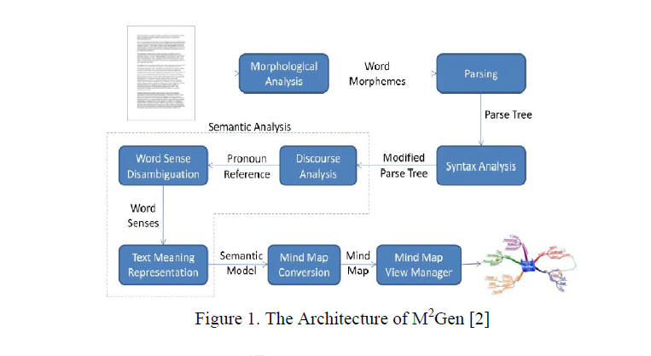

First, the English text is processed by morphological analysis in order to analyze each word into its lemma and affix along with its POS tag. The result of morphological analysis is then processed by parsing component by using CFG and top down chart parsing. Since not all parts of parse tree are used, then there is a parse tree modification process in the syntax analysis. The result is then used by semantic analysis to yield the semantic model. The semantic analysis consists of several sub components such as discourse analysis, word sense disambiguation and text meaning representation. The discourse analysis aims to solve the pronoun reference in sentences, the

word sense disambiguation aims to select the best sense of a single word, and the text meaning representation aims to transform the parse tree result into the semantic model. The resulted semantic model is then converted into Mind Map figure. The example of generated Mind Map figure is shown in Figure 2.

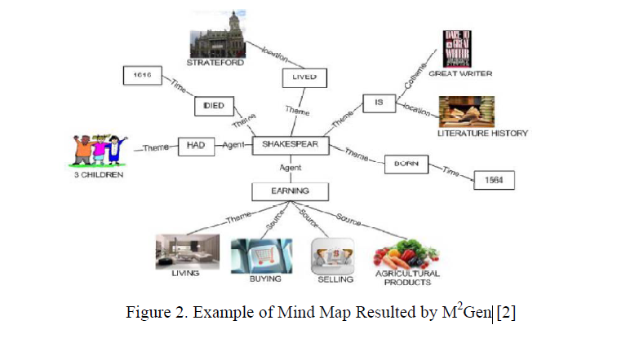

On the other hand :

* this version only supports single layer mind map and does not produce a hierarchical (multilevel)
* the images assigned to the nodes are not accurately representing them

## Generating Mind Map from Indonesian Text using Natural Language Processing (Athia Saelan, Ayu Purwarianti) in 2013

This make the process easier by generating mind map from text (here is Indonesian text) and providing mind map editor to manipulate the object and relation set.

To build such tool, They employ available Indonesian NLP (Natural Language Processing) tools.

There are three components needed: semantic net generator, mind map visualization and interaction handler. In the semantic net generator, the resulted first order logic (FOL) resulted by the semantic analyzer is changed into semantic net which is represented by list of objects and list of relations. The resulted semantic net is then visualized by using combination method of radial and layering drawing. The interaction is available for editing the object and the relation. The tool was then evaluated by 2 experiment set: testing the semantic net generation and testing the resulted visualization. The semantic net generation was evaluated by using the valid input text, while the visualization was evaluated by user acceptance test.

As the result, although the semantic net generation (from FOL) is a correct one, but the whole semantic analyzer for Indonesian text still has a low accuracy especially for complex sentence. As for the user acceptance test, the automatic generation still gives unimportant object which should be corrected by the interaction.

## Generating mind map from an article using machine learning: Nurrokhim in 2019

Data Collection: The data used in this study consists of two types, namely:

a. Article: article consists of several paragraphs, data in given to the expert for validation.

b. Validation Results: articles that have been marked topic sentence in each paragraph.

Model design: At this stage there are several things that are developed that is Information Retrieval Approach where in it there is a pre-processing text process, Core NLP, Part of Speech Tagger. At the process of text processing technique used is segmentation, tokenization. Data is processed to separate sentences into words per word text pre-processing, then done core NLP and part of speech tagger to determine the word type per word in the sentence. There are three types of words specified, among others, Noun, Verb, and Adjective. The next process is the feature extraction in which there is a process: frequency, sentence position value, and similarity with title and sub-title. After that, sentence scoring is done to sum up the value obtained from the feature extraction. Then the last stage is the sentence ranking and summary extraction after the calculation is done it will be selected the greatest value to be the topic sentence of the paragraph.Testing is done by comparing the concept map of automatic generation with concept map made by experts , The results showed 52.5% accuracy the accuracy of the system is medium.

# 3-Risk/Constraints

## 3.1-Risk

A possibility of suffering from loss . Loss can be anything, increase in production cost, development of poor quality software, not being able to complete the project on time. Software risk exists because the future is uncertain and there are many known and unknown things that cannot be incorporated in the project plan.

In order to identify the risks that our project may be subjected to, it is important to first study the problems faced by previous projects. Study the project plan properly and check for all the possible areas that are vulnerable to some or the other type of risks. The best ways of analyzing a project plan is by converting it to a flowchart and examine all essential areas. It is important to conduct few brainstorming sessions and mind map to identify the known unknowns that can affect the project. Any decision taken related to technical, operational, ,internal or external factors should be evaluated properly .

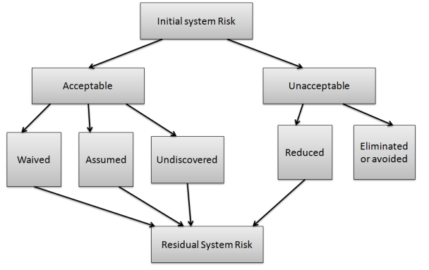

Risk Planning

**Consequently** we will provide problems that faced previous projects and potential risks :

* The accuracy of the mind maps produce by the model may be low in accuracy compared to the mind maps that humans produce for the same articles or reports
* Complex sentences that need to focus and understand the context of the whole sentence. The model may not define its meaning precisely or it may show undesirable results for these sentences.
* If we try to add more than one language that the model can deal with, we will face many difficulties, most notably languages that contain many words and there is a difficulty in understanding their grammatical rules, and among these languages of course is the Arabic language, and accordingly we think that we will focus on the English language.
* The M2Gen version only supports single-layer mind map and does not produce a hierarchy (multi-level), and we believe that we should solve this problem in order for our model to produce mind maps whose efficiency is higher than that of the mind maps produced by M2Gen.

## 3.2-Consraints

To minimize constraints, then, it’s first helpful to understand their definition.

A constraint is anything that slows a system down or prevents it from achieving its goal. We could think of a constraint as a bottleneck in our processes that impedes our progress.

There are many, many different types of constraint.

However, it’s important to note that a system cannot have hundreds or thousands of constraints at one time. The maximum is capped. This is because constraints are the factors that most limit your production.

* people constraints are caused by not having enough skill for a project or having skills not related to our project but we distribute tasks that suitable to each one as we can . While this can be the case, in software development, having too many skilled people on a project can also cause a people constraint. (Known as and explained by Brooks’ law.)
* The idea of the project should be purposeful and its implementation solves an existing problem or facilitates doing work that would have required much effort and time to complete it . And we believe that our project meets these conditions. **otherwise** You're spending time creating things that consumers don't want or need.
* Equipment constraints are those delays caused by faulty, slow, or out of date equipment or a lack of sufficient space. In our project it might be a lack of devices And in this case we may go to the web because it does not require devices with high capabilities, all we need are devices that can run the browser, and unlike that in Android, which requires devices with specific capabilities to run Android Studio

# 4-Project plan

Project planning is at the heart of the project life cycle, and tells everyone involved where we are going and how we are going to get there.

***Generate mind map automatically from articles using Natural language processing(NLP)*** is idea for our project and this is what we want to go to achieve

But How?

the project work plan can be shown using Gantt chart to illustrate phases and tasks:

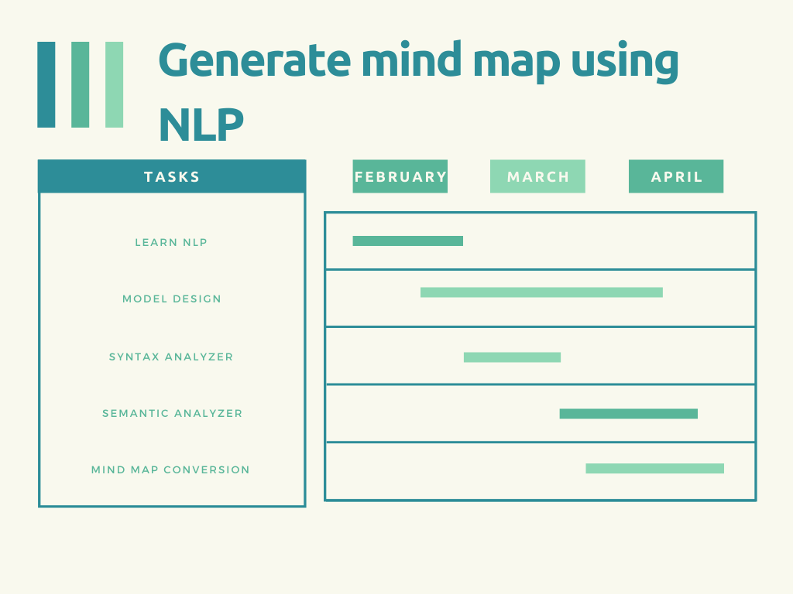

Gantt Chart

# 5-Software Quality Assurance (SQA)

(SQA) is simply a way to assure quality in the software. It is the set of activities which ensure processes, procedures as well as standards suitable for the project and implemented correctly.

|  |  |
| --- | --- |
| **list of SQA activities** | **Description for each activity** |
| Executing Formal Technical Reviews: | An FTR is done to evaluate the quality and design of the prototype.   * In this process, a meeting is conducted with the team to discuss regarding the actual quality requirements of the software and the design quality of the prototype. * This activity helps in detecting errors in the early phase of SDLC and reduces rework effort in the later phases. |
| Controlling Change: | In this activity, we use a mix of manual procedures and automated tools to have a mechanism for change control.   * By validating the change requests   evaluating the nature of change and controlling the change effect,   * it is ensured that the software quality is maintained during the development and maintenance phases. |
| Having a Multi- Testing Strategy: | By multi-testing strategy, we mean that one should not rely on any single testing approach, instead, multiple types of testing should be performed so that the software product can be tested well from all angles to ensure better quality |
| Enforcing Process Adherence: | This activity insists the need for process adherence during the software development process. The development process should also stick to the defined procedures.  This activity is a blend of two sub-activities which are explained below in detail:   * Product Evaluation:   This activity confirms that the software product is meeting the requirements that were discovered in the project management plan. It ensures that the set standards for the project are followed correctly.   * Process Monitoring:   This activity verifies if the correct steps were taken during software development. This is done by matching the actually taken steps against the documented steps. |

Table1: QSA

# 6. System requirement specification

## 6.1 Function Requirements

This section **Function Requirements** contains the specification of function requirements of the system, below tables are the lists of function requirements

### 6.1.1 Manage Articles [MA]:

|  |  |
| --- | --- |
| Requirement ID | Requirement Description |
| MA 1 | System allow users who are logged to it to **(Add / Upload)** New articles |
| MA 2 | System allow user who are logged to it to **(Update)** his articles |
| MA 3 | System allow user who are logged to it to **(Delete)** his articles |
| MA 4 | System allow user who are logged to it to **(read statistics)** of his articles |

Table 2 Manage Articles

### 6.1.2 Liked Articles [LA]:

|  |  |
| --- | --- |
| Requirement ID | Requirement Description |
| LA1 | User who logged to system can **put likes** to the articles |

Table 3 Likes

### 6.1.3 Reply on Articles / Comment on Articles [CA]:

|  |  |
| --- | --- |
| Requirement ID | Requirement Description |
| CA1 | User who logged to system can **comment on** the articles |

Table 4 comment

### 6.1.4 Generating Mind-map [GM]:

|  |  |
| --- | --- |
| Requirement ID | Requirement Description |
| GM1 | System **generating mind map automatically** To the uploaded Articles |

Table 5 Mind Map

## 6.2 Non- Functional Requirement

### 6.2.1: Performance Requirement [PR]

|  |  |
| --- | --- |
| Requirement ID | Requirement Description |
| PR1 | System must respond The Operations in less 7 seconds for user |
| PR2 | The System should be **compatible** with all android versions and browsers |
| PR3 | **"Accessibility/direct access"**  System should be accessible for all |
| PR4 | **"Maintainability"** Make the system capable to use in order to achieve a particular goal |
| PR5 | **"Extensibility"** The ability to make extend a system and this is by can be through the modification of previously existing functionality or through addition of new functionality in the system |
| PR6 | **"Usability"** the system provide for user capability to use in order to achieve a particular goal |
| PR7 | **"Privacy"** the system must be able to protect user information and articles from unauthorized person |
| PR8 | **"Security"** the ability to provide protection to the system from attack and intrusions. |

Table 6: performance Requirement

### 6.2.2: Safety and Security Requirement [SSR]:

|  |  |
| --- | --- |
| **Requirement ID** | **Requirement Description** |
| SSR1 | The System must handle safe login and logout through session. |
| SSR2 | Hashing technology and Algorithms should be used to handle the secure login for users. |
| SSR3 | The database should be secured from SQL Injection to prevent leak or loss of information |
| SSR4 | The system could use SSL (Secured Socket Layer) certificates to secure the data transmitted. |

Table 7 Safety and security Requirement

### 6.2.3: Reliability [R]:

System should be designed in modular manner to ease in software maintenance. By designing modularly, we are able to reduce coupling allowing each module to perform a specific function.

|  |  |
| --- | --- |
| **Requirement ID** | **Requirement Description** |
| R1 | The Program should be **reliable** and provide catching of exceptions so that unintended result do not occur such as system crashes or data validation failure. |

Table 8: Reliability

### 6.2.4 Other Software Quality Attributes:

#### 6.2.4.1 Usability:

**Usability** the system provide for user capability to use in order to achieve a particular goal.

The system should have user-friendly interface

#### 6.2.4.2 Availability:

The system must be available 24/7, with no more than 20 minutes down time per day

# 7- Use-case

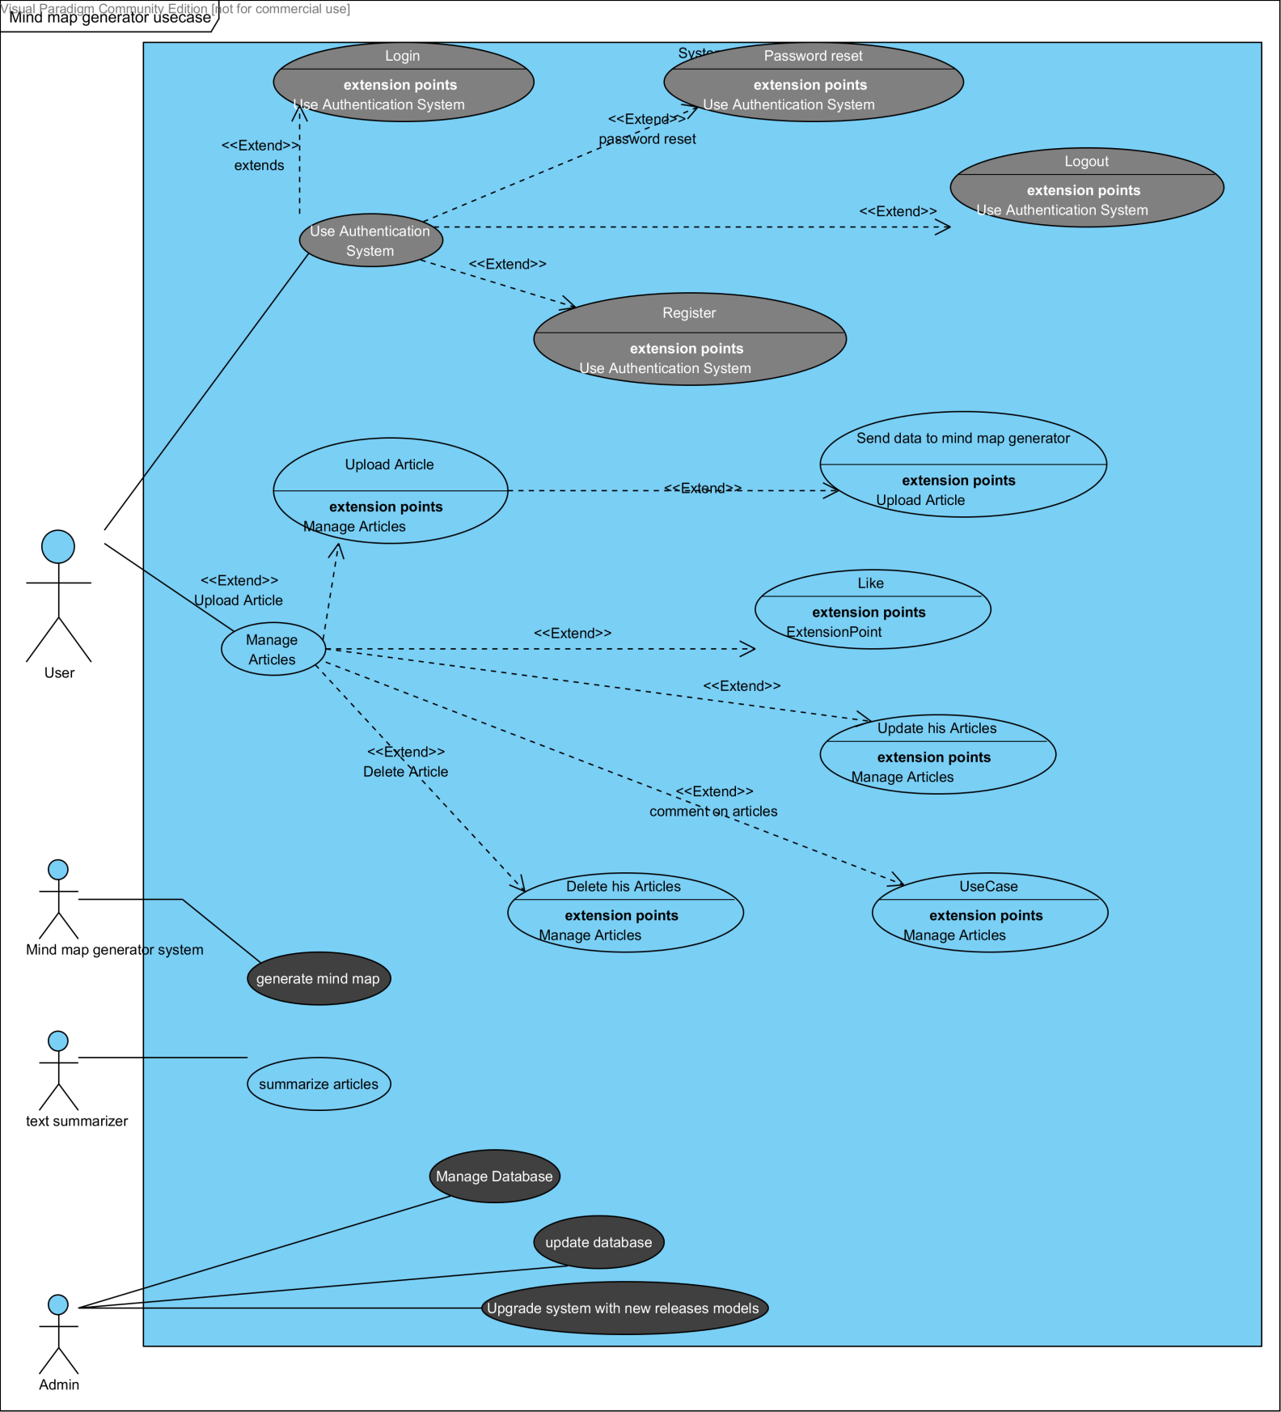

## 7.1-Use-case description

**Table 1: Login**

|  |  |
| --- | --- |
| Use case Name | Login |
| Scope | Product |
| Level | Task |
| Description | This use case describes how a user log into the System to leave a comment ,like and upload articles |
| Step performed | This use case starts when the actor wishes to log into the system.   1. The actor enters his/her name and password 2. The system validate the entered username and password and logs the actor into the system. |
| Alternative path | Invalid Username/Password  When user enters an invalid username or invalid password, system displays an error message.  The use choose either return to the beginning of the Basic Flow or cancel the login, at which point the use case ends. |
| Precondition | The system is in the login state and has the login screen displayed. |
| Post conditions | If the use case was successful, the actor is now logged into the system. if not, the system state is unchanged. |

Table 9: Login

**Table 2: Manage Articles**

|  |  |
| --- | --- |
| Use case Name | Manage Articles |
| Scope | Product |
| Level | Task |
| Description | This use case allows to the user to dealing with articles in the system of articles. This includes adding, modifying, and deleting his Articles from the system. |
| Step performed | This use case starts with user want to add, change, delete, articles in his profile in the system.   1. The system request the user specify the function he would like to perform ( either Add an Article, Update his articles, delete his article ) 2. Once the user provide the requested information, one of the sub flows in executed.   If the user select **"Add an article",** the **Add an Article** sub flow is executed.  If the user select **"Update an article",** the **Update an Article** sub flow is executed.  If the user select **"Delete an article",** the **Delete an Article** sub flow is executed.  Add/Upload Article   1. The system requests that the user enter the Article information. This includes :  * Article Text * Mind map addition to the auto-generated one .  1. Once the user provides the requested information, the system generates and assign unique id number to the article. The article is uploaded to the system. 2. The system provides the user with the new article id .   Update an article   1. The system requests the user choose the article. 2. The user choose the article , the system retrieves and displays the article information. 3. The user makes the desired changes to the article information. This includes any of the information specified in the Add /Upload an Article sub-flow. 4. Once the user updates the necessary information, the system updates the article information and generate another mind map and conclusion to it.   Delete An Article   1. The system requests the user to choose one of his articles . 2. The user choose one. The system retrieves and display its information. 3. The system prompts the user to confirm the deletion of the article. 4. The user verifies the deletion. 5. The system deletes the articles from the system. |
| Alternative path | Article Not found  If, in the Update a student or delete an article sub-flows, an article with a specified id number does not exists, the system displays an error message . The user can choose different id number or cancel the operation or this may mean that the article is deleted previously ,at which point the use case ends.  Delete Cancelled  If, in the Delete an Article sub-flow, the user decides not to delete the student, the delete is cancelled and the Basic flow is re-started at the beginning. |
| Precondition | The user must be logged onto the system before this use case begins. |
| Post conditions | If the use case was successful, the student information is added, updated or deleted from the system. Otherwise , the system state is unchanged. |

Table 10: Manage Articles

# 8- System architecture



**User**

Mobile application

**Choose service**

**Arabic // English**

# 9- Database Schema

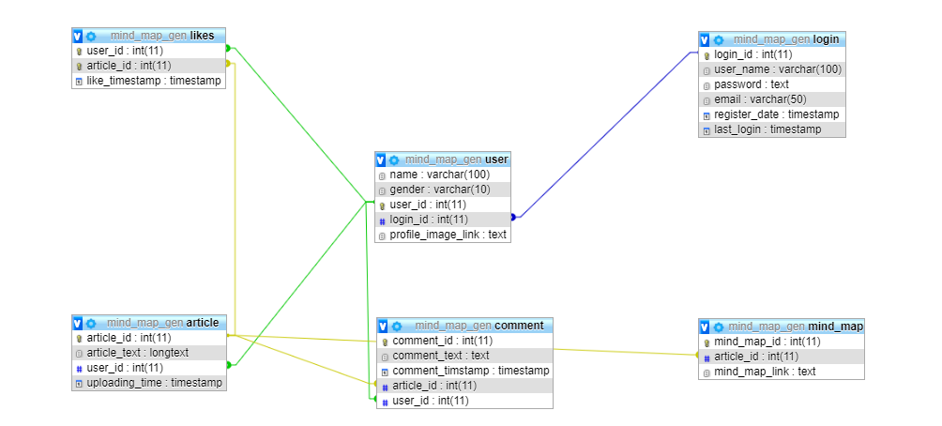

# 10- Interaction diagram

***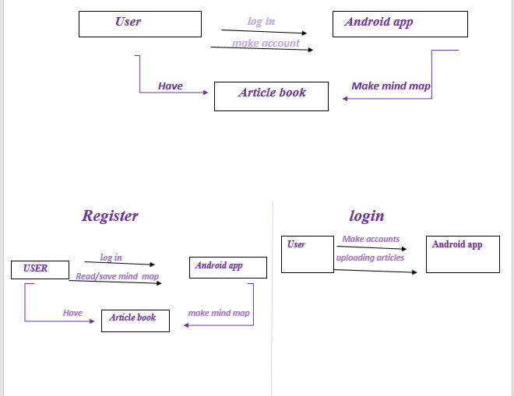***

# 11- Class Diagram

# 12. Sequence diagram

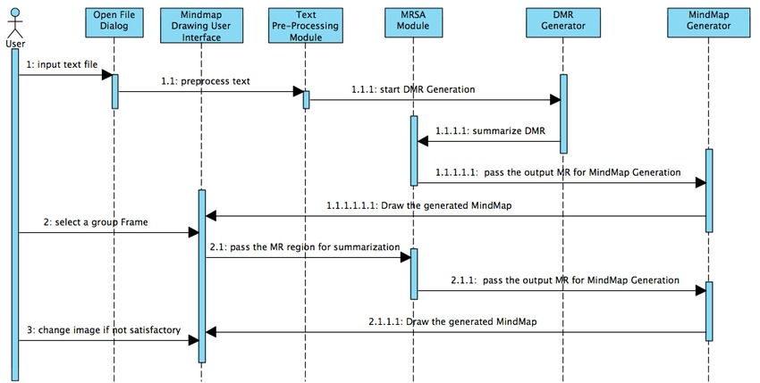

# F:\New folder\FCI\4\Grad Work\Abdo\photo_2021-01-15_09-38-49.jpg13- Expected Deployment:

# 14-State for Project

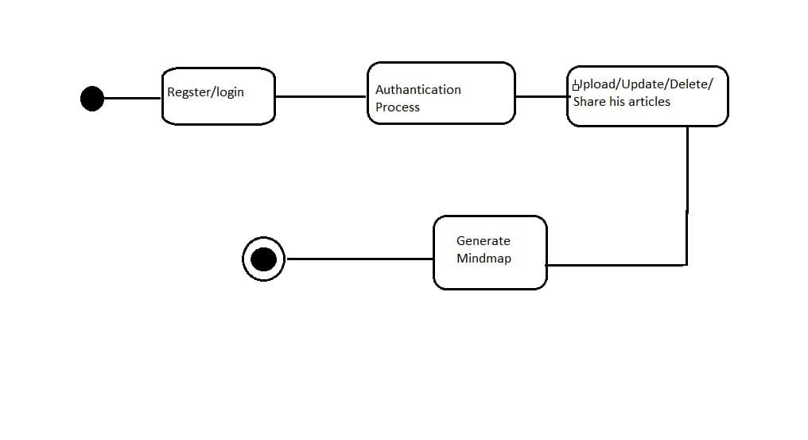

# 

# 15-Conclusion

We have discussed in this document more than one service that can help people to read and extract important information from texts because we believe in the importance of reading and it is the first inspiring activity for all creative people who changed the course of history, and this is precisely a point that we referred to in the Abstract.

It is clear that we have focused on the mind map because of its advantages, and if it is extracted automatically from the texts, it will be an easy way to understand the content and there is consensus on its importance and the ease of remembering the mind map.

We face many difficulties, including, for example, the production of two versions of the application, one in Arabic and the other in English, and the lack of educational content for natural language processing (NLP)compared to other common topics.

All these challenges motivate us more for success and for the benefit to prevail and for the largest number of people to benefit from the application, and life is full of success and failure.

We hope that our application will not fail, and God willing, with our cooperation, we will be able to achieve the achievement.